2017暑期海外游学项目介绍
美国西弗吉尼亚大学
Introduction of West Virginia University

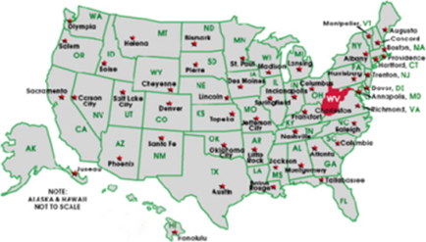
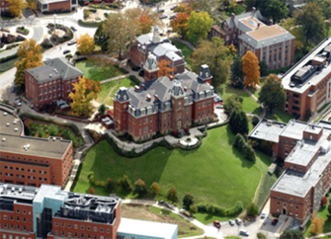
西弗吉尼亚大学（WVU）建于1867，是西弗吉尼亚州的旗舰大学，共有3个校区，15所学院，在校师生35，000人。西弗吉尼亚大学被卡耐基高级教育基金会评为一级研究类州立大学。
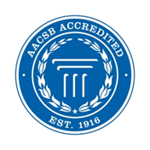
WVU商学院是经过AACSB机构认可的、全美TOP100商学院。商学院开设的专业在全美拥有较高的知名度，其中Online EMBA项目2015年在全美排名第25名（US New and World Report）；人力资源管理硕士全美排名前10名；金融硕士是CFA全球认证项目，全美排名第43名；全日制MBA全美排名92名。近年来，商学院培训了500多位来自北京、上海、天津和陕西等地的企业高管和政府官员。
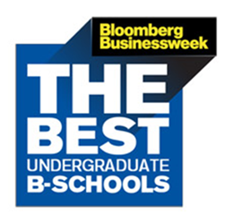

总费用约为3.1万人民币。
全美最好商学认证院AACBS认证商学院
2017 WVU Academic and Cross-Culture Experience Program
西弗吉尼亚大学暑期学术和校园文化访学项目
Date | July 9  Sunday | July 10  Monday | July 11  Tuesday | July 12  Wednesday | July 13  Thursday | July 14  Friday | July 15  Saturday
9:00-12:00 |  |  | 10:00am Program Orientation | Lecture: Personal Finance by Dr. Riley | Visit Scenic Rocks Sate Park at West Virginia | Lecture: International Business Strategy by Dr. Dawley | 9:00-15:00 WVU Challenge Courses
13:30-16:30 |  |  | Campus Tour and visit the University Town Center | Lecture: American English and Culture by Mr. Myers |  | Lecture: American English and Culture by Mr. Myers (visit Morgantown Museum)
18:00-20:00 |  | Pick up the group at Pittsburgh Airport and Check in WVU Dormitory | Activity at Student Recreation Center | Activity at Student Recreation Center |  | Visit the Chinese Church

2017 WVU Academic and Cross-Culture Experience Program
西弗吉尼亚大学暑期学术和校园文化访学项目
Date | July 16  Sunday | July 17  Monday | July 18  Tuesday | July 19  Wednesday | July 20  Thursday | July 21  Friday | July 22  Saturday
9:00-12:00 | Visit American Church and talk to local people | Lecture: Global Economy Outlook by Dr. Deskins | Lecture: Tourism and hospitality by Dr. DeMarco | 8:00-18:00, Visit the Capitol of WV Charleston | Lecture: Leadership Development by Dr. Gavin | Lecture: Financial Investment by Dr. Naomi Boyd | 9:00-16:00, Go Shopping at Tanger Outlets, Washington, PA, Leave at 9:00am
13:30-16:30 | Visit to Cheat Lake, Cooper Rocks July 18 | Lecture: U.S. Employee Benefits by Mr. Zhao | Lecture: American English and Culture by Mr. Myers |  | Lecture: American English and Culture by Mr. Myers | On-site teaching: how to play baseball and practice at Marilla Park
18:00-20:00 |  | Visit Morgantown Mall | Activity at Student Recreation Center |  | Watch Movie at Hollywood Center | Activity at Student Recreation Center

WVU Academic and Cross-Culture Experience Program
西弗吉尼亚大学暑期学术和校园文化访学项目
Date | July 23  Sunday | July 24  Monday | July 25  Tuesday | July 26  Wednesday | July 27  Thursday | July 28  Friday | July 29  Saturday
9:00-12:00 | Visit Pittsburgh, and the University of Pittsburgh, Carnegie Mellon University  Watch Pirates Baseball Match in Pittsburgh | Lecture: International Business and Finance by Dr. Chow | Lecture: International Business and Finance by Dr. Chow | Drive to Washington DC, and stop at Hagerstown Outlets for 4 hours’ shopping | One-day Washington DC tour  8:50am, Capitol Hill Tour  11:00am, Congress Library Tour  1:00-5:00pm, Museums Tour | Visit Georgetown University, White House, and Lincoln Memorial, and others | leave Washington DC for Shanghai, China
13:30-16:30 |  | Fun Olympic Games with American and Germany Students | Lecture: Ethical use of the Internet by Graham Peace  Certificate Awarding
18:00-20:00 |  |  | Pack up luggage
This training agenda is subject to change.

授课教师
1 | Dr. Graham Peace | 西弗吉尼亚大学商学院副院长、教授、博士生导师 | Joyce.heames@mail.wvu.edu
2 | Dr. Mark Gavin | 西弗吉尼亚大学商学院副院长、教授、博士生导师 | Mark.gavin@mail.wvu.edu
3 | Dr. Victor Chow | 西弗吉尼亚大学教授、CFA、中国工商中心主任、孔子学院院长、博士生导师 | Victor.chow@mail.wvu.edu
4 | Dr. William Riley | 西弗吉尼亚大学金融系主任、教授、博士生导师 | William.riley@mail.wvu.edu
5 | Dr. Naomi Boyd | 西弗吉尼亚大学金融系主任、教授、博士生导师 | Naomi. Boyd @ mail.wvu.edu
6 | Dr. John Deskins | 西弗吉尼亚大学首席经济学家、经济研究局局长、教授 | John.deskins@mail.wvu.edu
7 | Dr. David Dawley | 西弗吉尼亚大学全球合作中心主任、国际商务教授 | David.dawley@mail.wvu.edu
8 | Dr. Frank DeMarco | 西弗吉尼亚大学商学院旅游管理学教授 | Frank.demarco@mail.wvu.edu
9 | Mr. Michael Zhao | 西弗吉尼亚大学中国工商中心副主任、孔子学院副院长 | Zhongmin.zhao@mail.wvu.edu
10 | Mr. Jeremy Myers | 西弗吉尼亚大学中国中心英语和美国文化教师 | Jeremy.myers12@yahoo.com

